POLITEHNICA University of Bucharest

Faculty of Engineering in Foreign Languages

Systems Engineering Project

Smart Tourism

Students: Deleanu Teodora

Dinescu Ioana

Ionita Raluca

Ursu Andrei

Group: 1241

2020

Table of contents

1. Problem definition and project scope
2. Current approaches
3. Stakeholders and their needs
4. System requirements
5. Our planned approach
6. Challenges and issues that you face
7. Quality assurance plan
8. Conclusions
9. References
10. Annexes
11. **Problem definition and project scope**

Since the eighteenth century when private collectors decided to open them to public were inspired by a sense of curiosity and wonder about the products of nature. Nowadays, the museum experience has been lost, in part, due to the information overload coming via the media and the impersonal nature of the museum visit.

Augmented reality is the process of using technology to superimpose images, text or sounds on top of what a person can already see. It uses a smartphone or tablet to alter the existing picture, via an app. The user stands in front of a scene and holds up their device. It will show them an altered version of reality.

In the age of speed and ‘smart’, augmented reality plays a bigger role in every domain. This was the base for our project. We aim to enhance the experience of visiting a museum through AR technology.

There are many possibilities for the use of AR in museums. The most straightforward way is to use it to add explanations of pieces. This means visitors will get more information when they view exhibitions using AR. Museums could even use it to display digital versions of artists next to their work. These 3D personas are then able to provide a narration. AR gives an opportunity to add a third dimension to displays, bringing objects or scenes to life.

In the present, many museums have already implemented AR technology to their exhibitions:

* Art museums (The Art Gallery of Ontario, Toronto)
  + Recreate scenes from pictures
* Space museums (The Kennedy Space Centre, Merritt Island)
  + Recreate the movement of stars
* Science museums (Museum Of Science And Industry, Tampa, Fl)
  + Allow people to ‘meet’ with wild animals and dinosaurs

For this reason, we cannot say that we develop a new system, but adapt an already existing one.

We have opted to aim our project to national history ones such as National Museum of Natural History Grigore Antipa from Bucharest, Romania.

**Why** do we think it is a good idea?

* AR is engaging
  + Good stories blended with good AR experiences make knowledge reach out to more audiences. When exciting facts are displayed with AR, users become more connected and thus more interested in learning, informally, about themes and sub-themes.
* AR brings artifacts to life
  + Museums typically tend to present static exhibitions. And this is quite understandable since one of their primary purposes, apart from spreading knowledge, is to preserve and protect their valuable pieces. AR has the ability to change this motionless characteristic.
* AR is fun and interactive
  + Many museums attract families and young visitors by adding a little fun and play to their exhibits. This is an effective win-win tactic, and AR gaming is the new way to do so. By integrating some playful AR elements into family-oriented games, families can play and learn together around a city, a garden, a museum or other locations.
* AR is readily available and easily accessible
  + AR experiences can run on most existing smart devices and do not require extra equipment to work. Those not living under a rock, most likely know how common such devices are in practically everyone’s modern daily lives. This means that even though AR may not yet be as widely known as virtual reality (VR), for example, it has the potential to become a much more used, and much more world-changing technology.
* AR gives visitors an extra reason to visit – and revisit
  + Let’s face it; if museums want their audiences to come back, they have to give a good reason for them to do so. Since AR can be combined with other technologies, museums are increasingly using it to refresh outdated exhibitions.

**What** do we plan to provide?

To provide a full-fledged web application that can be used as easy on any platform. The application, for the moment, is designed for a specific type of museum, but in the future can be designed by specific needs and wishes.

From our application, customers not only can download the AR application, but they can also buy tickets and book buses.

1. **Current approaches**

Some of the current museums that use Augmented Reality have already been mentioned above, like The Art Gallery of Ontario, Toronto, which had the idea to give “life” to the characters in the art pieces and provide the visitors with a modern perspective by using their smartphones or tablets.

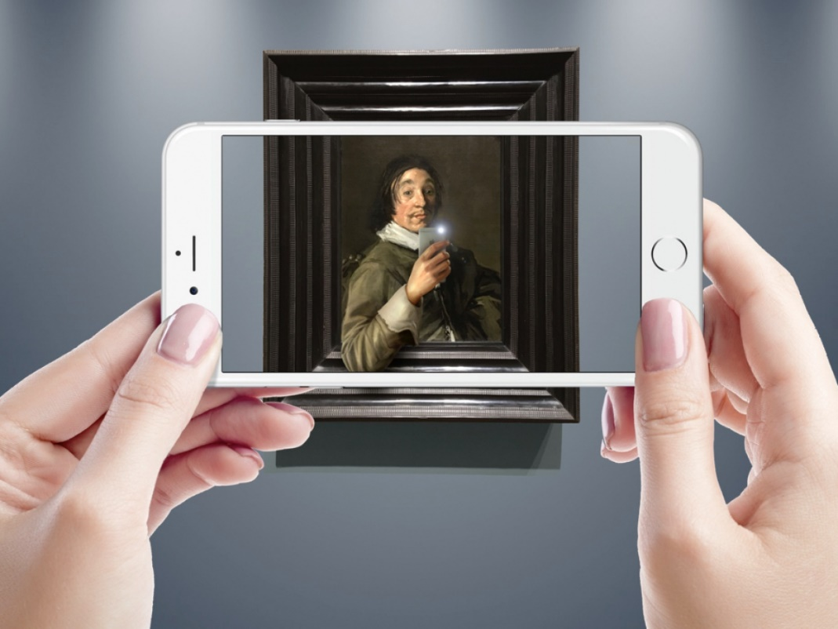

Fig.1 The Art Gallery of Ontario, Toronto

There is also the National Museum of Singapore which allows visitors to use their smart devices in order to visualize in AR the skeleton of an Indian Fin whale in the exact place where it used to be exposed physically in the past. When the visitors stand under the glass passage on the second level of the museum, they will not only see the whale skeleton on their screen, but also what the whale might have looked and sounded like. They can even take selfies with it.

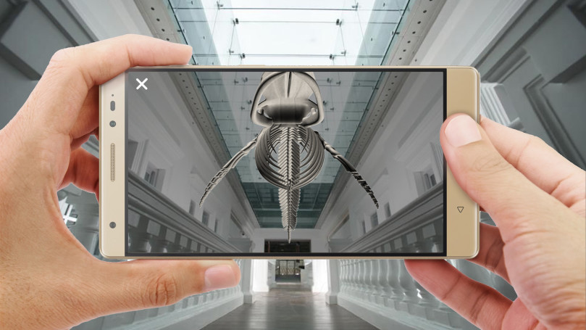

Fig.2 National Museum of Singapore

One other museum which chose to offer a new perspective of museum tours is The Detroit Institute of Art. Their approach was to build a mobile app called Lumin that guides the visitors around the museum and uncovers different kinds of content about the objects chosen for augmentation. For example the application users can take a look at the wrappings of a mummy and see the skeleton inside.

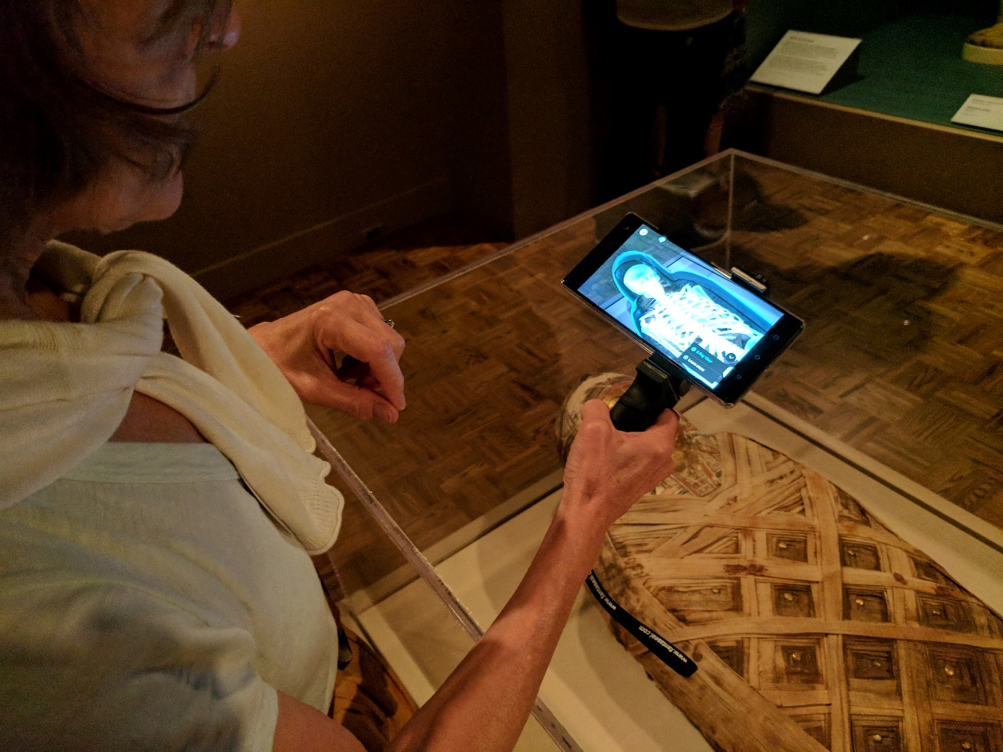

Fig.3 The Detroit Institute of Art

The best example is one that relates to our idea, the approach the Smithsonian Institution in Washington D.C. had as a natural history museum. In 2017 they thought about bringing a new dimension to the experience with the Skin and Bones application for iOS devices. Its purpose was to recreate the looks of the animals when a visitor points the device’s camera at their bone structures. This allows for a direct comparison of the actual skeleton and the virtual image of the living animal.

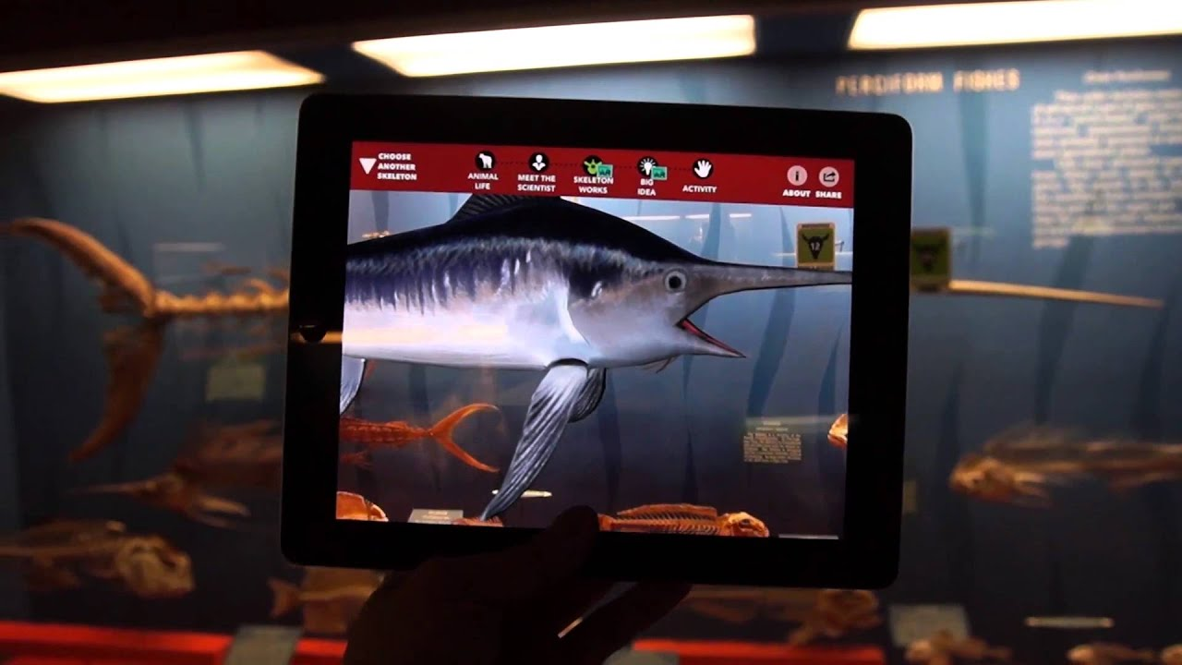

Fig.4 Smithsonian Institution in Washington D.C.

This is only one of the uses of Augmented Reality technology at the Smithsonian, they also had an exhibit in partnership with the FBI, where they recreated a crime scene and with the help of AR, the visitors could find evidence and be told how that evidence is processed and used for further investigations.

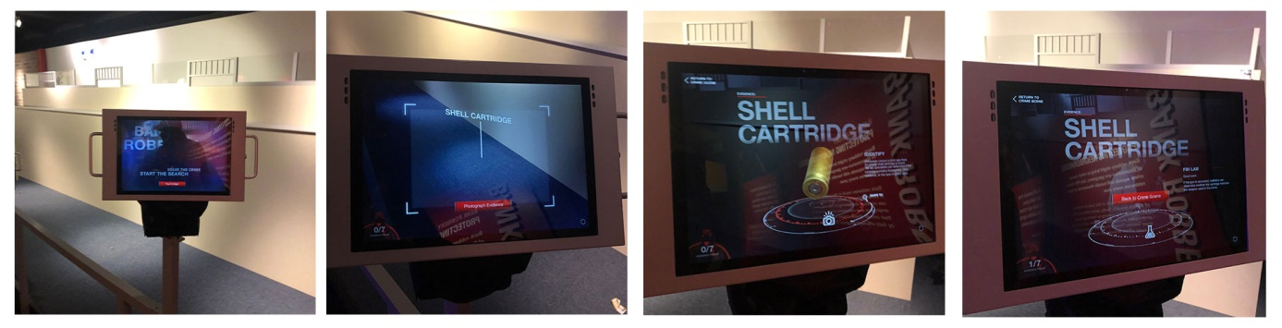

Fig.5 Smithsonian Institution - Crime Scene

These are only some of the museum AR examples, which are great proof that the limit of this kind of technology is the imagination. However, there are some drawbacks that will be presented further.

These existing solutions that are implemented in many museums around the world do not cover the entire collection of pieces, they are either made for a certain exhibition or part of the museum, or even for temporary exhibitions only. An ideal scenario and the scope of our project is to use AR for the whole museum experience. This means that for every exhibit there is AR content with audio descriptions.

Another drawback of such solutions is that some people, especially the elderly are having trouble adopting new technologies and many of them do not own a smartphone or a tablet, so AR is off limits in this case. Therefore, there is a certain public that will not appeal to this kind of experience, however this should not stop museums or any other places from implementing such solutions because most people enjoy technological advances and the experiences that can be provided in a virtual manner.

The current approaches are very nice ideas, and they provide users with very new and interesting experiences while visiting a museum and that means AR technology is a very powerful tool that is in continuous expansion because it brings the ability to challenge our imagination and create experiences that were not possible before. This technology comes with endless possibilities to make the public interact with the exhibits of a museum.

1. **Stakeholders and their needs**

Stakeholders are individuals, groups or organizations impacted by the outcome of the project. Some examples of key stakeholders are creditors, directors, employees, government (and its agencies), owners (shareholders), suppliers, unions, and the community from which the business draws its resources.

Stakeholders may vary throughout the [life cycle](https://www.sebokwiki.org/wiki/Life_Cycle_(glossary)). Thus, in order to get a complete set of needs and subsequent requirements, it is important to consider all stages of the [life cycle model](https://www.sebokwiki.org/wiki/Life_Cycle_Model_(glossary)) when identifying the stakeholders or classes of stakeholders.

Every system has its own stages of life, which typically include stages such as concept, development, production, operations, sustainment, and retirement. For each stage, a list of all stakeholders having an interest in the future system must be identified. The goal is to get every stakeholder’s point of view for every stage of the system life in order to consolidate a complete set of stakeholder needs that can be prioritized and transformed into the set of stakeholder requirements as exhaustively as possible.

Examples of stakeholders are provided in the following table:

|  |  |
| --- | --- |
| Life Cycle Stage | Stakeholders |
| Engineering | research and development department |
| Development | design engineers, integration team, developers |
| Transfer for Production or for Use | operators |
| Logistics and Maintenance | support services |
| Operation | users (individuals, museum staff, administration staff), government |

For the main stakeholders these are their needs:

* Research and development department - are a key agent in the engineering part. Their job consists of researching the market, analyzing the already existing application which do similar things and find ways to improve/modify them s that the resulting app will be new and innovative.
* Design engineers - they need to create the design of the application based on the information gather by the research and development team.
* Developers - they are directly involved in the development of the application and they will implement the design made y the design team.
* Support services - they will offer support to after the app is launched.
* Government - some of the museums might be owned by the government and other by private institutions.
* Users:
* Individuals - people interested in visiting the museums. They need to be able to purchase tickets and AR guides and also book buses.
* Museum staff - edit the museum’s page. Manage the reservations, schedule guides.
* Admins - give privileges to users, maintenance of the website and of the user base.

1. **System Requirements**

We have split the requirements in 4 categories:

* Financial requirements

The project will require a large financial investment. We have estimated that the sum of 750,000 euros should be sufficient for the first phase of the project which involves creating the website and the AR guide of only one museum.

* Human resources

Arguably one of the most important resources are the people working to create the application. For the successful engineering and development of the project we have identified the following departments/teams as necessary:

* Research team
* Development department
* Testing department
* Application management team
* System integration team
* Support team
* Management team
* Marketing team
* Physical requirements

The main feature of our application which is the AR guide will e accessible through a smart phone therefore the user will be required to have one.

* Technical requirements

Whole application will be split into two parts: the mobile application and the web application.

1. The mobile application will have the AR guides.
2. The web application:

The web application will also have two sides:

1. Client side

* GUI module which will display the museum’s page and will allow the user to buy a ticket or book a bus ride.

1. Server side

* Data Processing Module
* Data Storage Module

1. **Our planned approach**

First of all, in order to describe the structure of our system, we created a WBS (Work Breakdown Structure). This WBS was made using Visual Paradigm and its purpose is to organize the team’s work into multiple manageable sections:

* Planning
* Requirements
* Design
* Development
* Testing
* Deployment and Service

Each of the tasks above has a number of subtasks, which were carefully divided to set the project’s achievements and milestones.

In order to have a more efficient planning for our project, we also created a Gantt Chart, from an online creator called Office Timeline, and its purpose is to illustrate the schedule of the project and the dependency relationships between the activities.

Furthermore, we also created SysML Diagrams for our application to analyze and describe the system in a more specific manner:

1. Use Case Diagram

This diagram represents the behavior of the system and shows a series of events which describe the interactions between the actors (User, Transport Company, Museum) and the system. Each event is in fact a use case which describes a certain action that is triggered.

1. State Machine Diagram

This diagram also describes the behavior of the system and consists in a series of events that can occur in a number of possible states.

1. Block Definition Diagram

This diagram describes the structure of the system, by providing a number of components and the interactions between them.

1. Package Diagram

This diagram also provides information about the structure of the system and it contains a number of packages with their dependencies. There are three major packages (Presentation Layer, Application Logic and Data Logic) and each of them contains one or more subpackages.

1. Requirement Diagram

This diagram provides for the system a set of requirements, along with their relations.

1. **Challenges and issues**

Like every project, it is certain that our application will face a number of challenges and issues along the way. There are several risks which can occur during the making of our project:

Firstly, there is always the possibility of existing misunderstandings between business partners, which could harm the project’s development.

Another huge risk would be the bugs from the coding part of the application, which can lead to malfunctions for the system. The testing part of our project could also be classified as a risk. The tests can fail, therefore making the application unreliable. The UI part of our application is a very important one. It can be either too complex, too crowded or not user friendly.

One other risk that we could have is the existing of other similar products which are already launched, and this could lead to a lack of clients for our own product. Bad cost estimation is another important risk, due to underestimating costs for our product.

Our aim is to make the best out of this project in order to ensure a fully functional, efficient and user-friendly application for the users.

1. **Quality assurance**

The quality assurance plan is designed to provide an insight of the value and performance of our product as well as a common ground for effective communication, documentation and, possible, correction.

In order to ensure the quality that we aim for, we have developed the following strategies:

* Identify standards that ensures the quality of both the development process and the resulting outputs
* Provide documentation for tools, methods and techniques for the insurance of quality
* Constantly monitor the development process.

The metrics we have thought of using are:

* Defect rate = number of defects/ number of code lines
* Test effectiveness = bugs found in tests/(bugs found in tests + bugs found after shipping) x 100

1. **Conclusions**

The world has evolved a lot since the eighteenth century when private collections have been exposed to the general public. Due to this, the interest in visiting museum has decreased dramatically. But, the same evolution can be the key of regaining it.

AR technology is enhancing the experience by providing additional information and 3D model just a touch of screen away of any visitor. And we are confident that our project of providing an easy-to-use, all-in-one platform for anyone to use is a solution for future.

1. **References**

[1] Mary Terrall, “Narrative and natural history in the eighteenth century”

<https://www.sciencedirect.com/science/article/abs/pii/S0039368117300766>

[2] Heidi L. Ballarda, Lucy D. Robinson, Alison N. Young, Gregory B. Pauly, Lila M. Higgins, Rebecca F. Johnson, John C. Tweddleb “Contributions to conservation outcomes by natural history museum-led citizen science: Examining evidence and next steps”

<https://www.sciencedirect.com/science/article/pii/S0006320716303512>

[3] Antonio G.Valdecasas, Virginia Correia, Ana M. Correas “Museums at the crossroad: Contributing to dialogue, curiosity and wonder in natural history museums”

<https://www.sciencedirect.com/science/article/abs/pii/S0260477905000750>

[4] Science for the Masses: Review of Life on Display: Revolutionizing U. S. Museums of Science and Natural History in the Twentieth Century by Karen A. Rader and Victoria E. M. Cain, University of Chicago Press, 2014

<https://www.sciencedirect.com/science/article/pii/S0160932716300588>

[5] <https://www.museumnext.com/article/how-museums-are-using-augmented-reality/>

[6] <https://www.wikitude.com/blog-ar-apps-for-museums-three-success-stories/>

[7] SEVOCAB: Software and Systems Engineering Vocabulary. Term: block diagram. retrieved 31 July 2008.

[8] <https://exhibits.si.edu/even-better-than-the-real-thing-augmented-and-virtual-reality/>

[9] “Impact of augmented reality technology on academic achievement and motivation of students from public and private Mexican schools. A case study in a middle-school geometry course”, María Blanca, Ibáñeza Aldo Uriarte, Portillo Ramón, Zatarain Cabada, María LucíaBarrón

<https://www.sciencedirect.com/science/article/abs/pii/S0360131519302878>

[10] “How augmented reality affects advertising effectiveness: The mediating effects of curiosity and attention toward the ad”, ShuaiYang, Jeffrey R.Carlson, SixingChen

<https://www.sciencedirect.com/science/article/abs/pii/S0969698919306149>

1. **Annexes**

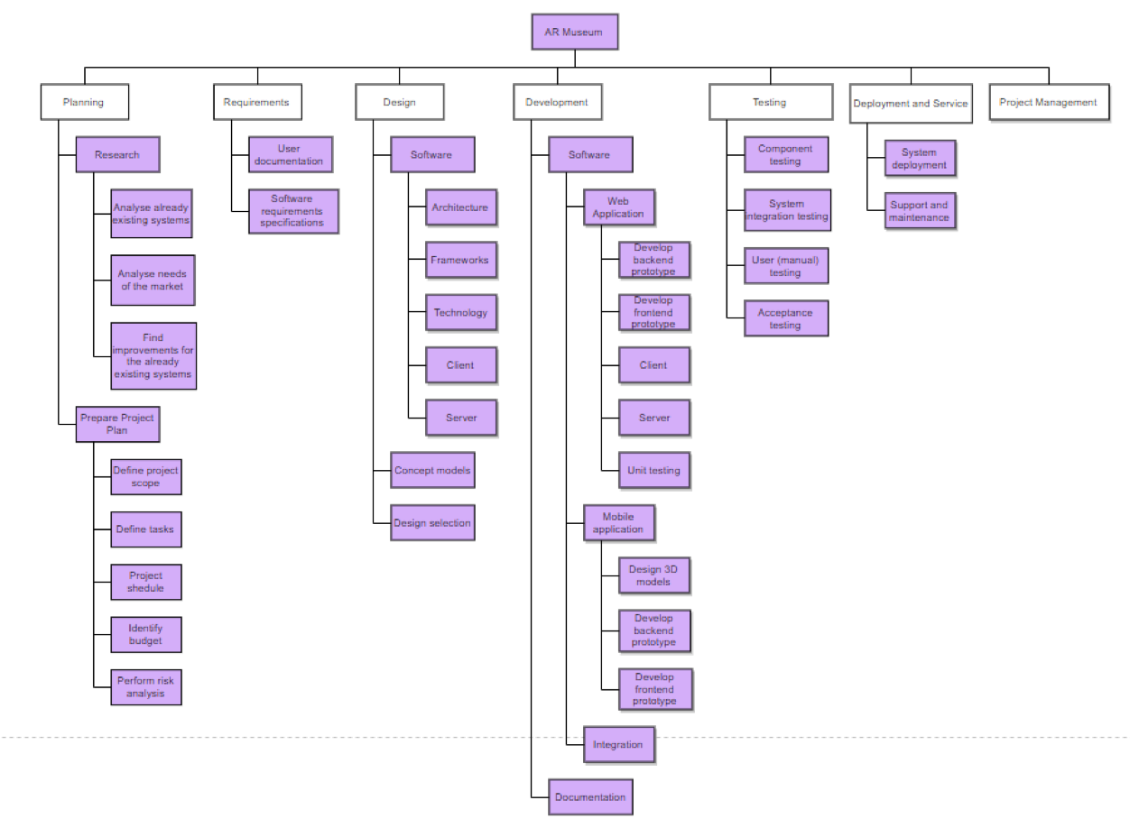

Fig.6 WBS

Fig.7 Gantt Chart

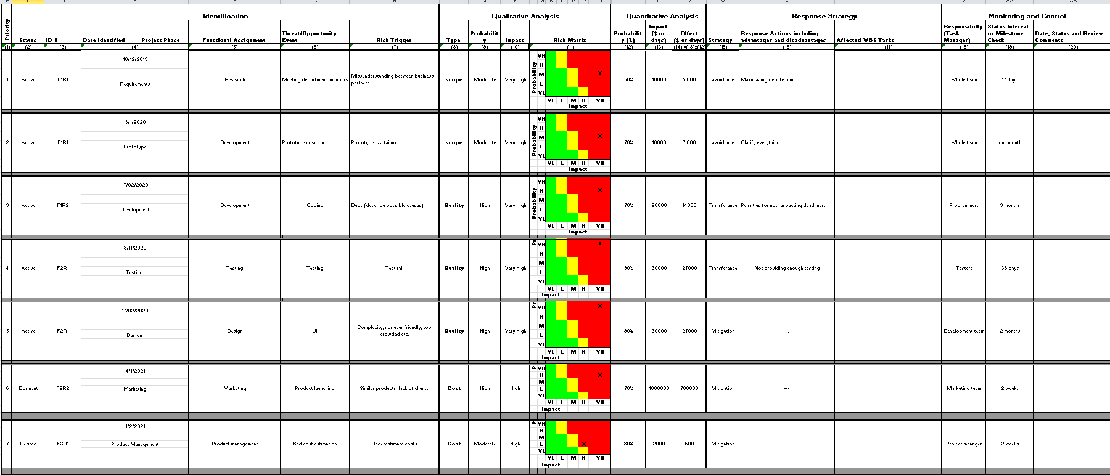

Fig.8 Risk Management

Fig.9 Use Case Diagram

Fig.10 State Machine Diagram

Fig.11 Block Definition Diagram

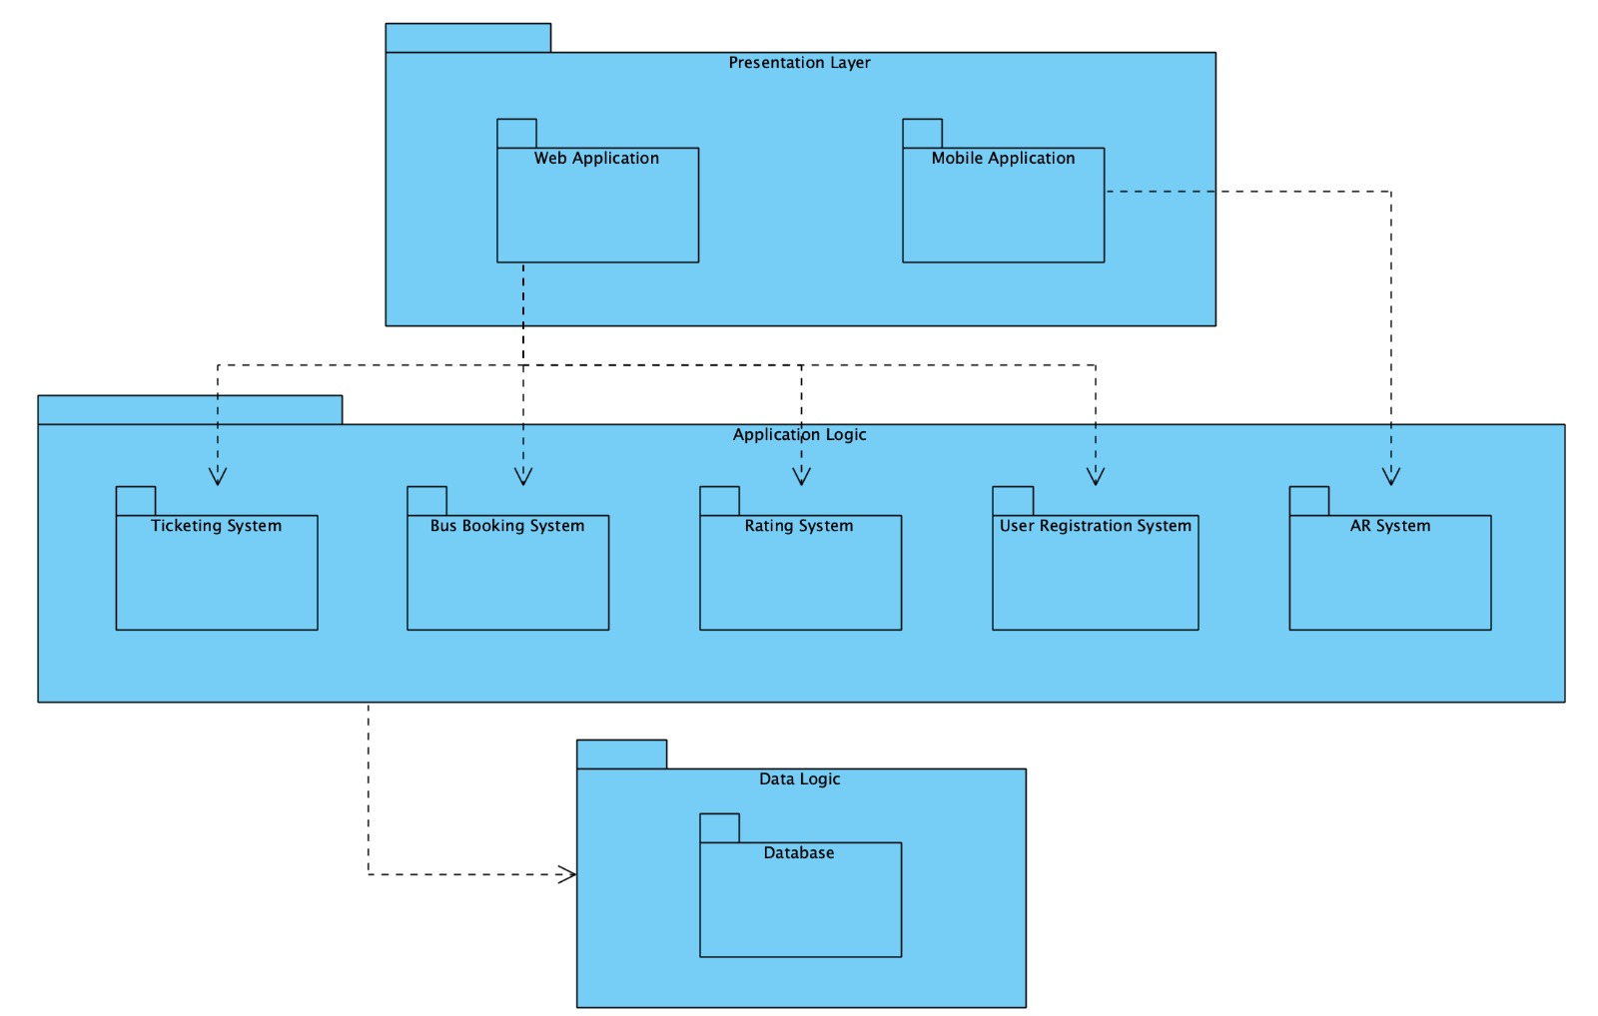

Fig.12 Package Diagram

Fig.13 Requirements Diagram